**REVISION HISTORY**

| **Date** | **Version** | **Description** | **Author** |
| --- | --- | --- | --- |
| 02/11/2023 | 1.0 | User Requirements Specification had been added. | Arda Onur, Kaan İşmen |
| 02/11/2023 | 1.1 | System Requirement Specification ,Document and System overview had been added. | Meriç Okçu, Ömer Özmeteler |
| 03/11/2023 | 1.2 | System Architecture had been added. | Arda Onur , Buğra Bedir |
| 04/11/2023 | 1.3 | UML Use Case had been added. | Arda Onur,Meriç Okçu ,Buğra Bedir |
| 05/11/2023 | 1.4 | Activity Diagram had been added. | Buğra Bedir, Kaan İşmen |
| 7/11/2023 | 1.5 | Description had been added . | Ömer Özmeteler |
| 15/11/2023 | 1.6 | UML Use Case has been changed. | Meriç Okçu, Kaan İşmen |
| 16/11/2023 | 1.7 | General fixes have been done. | Meriç Okçu, Kaan İşmen, Ömer Özmeteler |

**TABLE OF CONTENTS**

**Revision History**

**1** **INTRODUCTION**

***1.1*** ***Document overview page 3***

***1.2*** ***System overview page 3***

***1.3*** ***Abbreviations page 3***

***1.4*** ***References page 3***

***1.5*** ***Conventions page 3***

**2** **REQUIREMENTS**

***2.1*** ***User Requirements Specification page 4***

***2.2*** ***System Architecture page 4***

***2.3*** ***Use Cases and Usage Scenarios page 5,6***

***2.4*** ***System Requirements Specification page 7***

1. **INTRODUCTION**
   1. ***Document overview***

This document presents the software requirements specifications of AVEC software development project. It describes functional requirements, quality requirements, constraints, use cases, and usage scenarios. It also provides an overview of the system architecture.

* 1. ***System overview***

AVEC is a web-based e-commerce site that helps people, groups or companies sell their own products.

* 1. ***Abbreviations***

AVEC: Avielent E-Commerce

* 1. ***References***

| # | Document Identifier | Document Title |
| --- | --- | --- |
| 1 | AVEC-SDP-v1.9 | **Software Development Plan of AVEC (AVIELENT E-Commerce Software)** |

* 1. ***Conventions***

Requirements listed in this document are constructed according to the following structure:

**SRS-AVEC-001**

Description of AVEC-001 requirement

Every system requirement id includes the id of the corresponding user requirement as a prefix.

**SRS-AVEC-001.1**

Description of SRS-AVEC-001.1 system requirement, which is related to the user requirement SRS-SIS-001.

1. **REQUIREMENTS**
   1. ***User Requirements Specification***

**-SRS-AVEC-001**

AVEC will allow users to create a new account.

**-SRS-AVEC-002**

AVEC will enable users to put their products on sale.

**SRS-AVEC-003**

AVEC will allow users to search for the products they want.

**SRS-AVEC-004**

AVEC will allow users to purchase the products they want.

**SRS-AVEC-005**

AVEC will allow users to update their balance.

**SRS-AVEC-006**

AVEC will allow users to display the written product description.

**SRS-AVEC-007**

AVEC will allow users to change their password.

**SRS-AVEC-008**

AVEC will allow users to change the description of the product.

**SRS-AVEC-009**

AVEC will allow users to give a star to the product.

* 1. ***System Architecture***

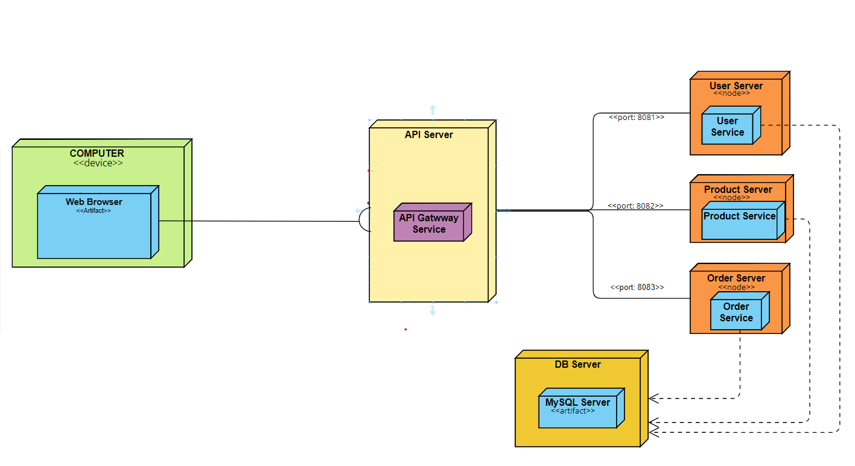

* 1. ***Use Cases and Usage Scenarios***

***UML USE CASE:***

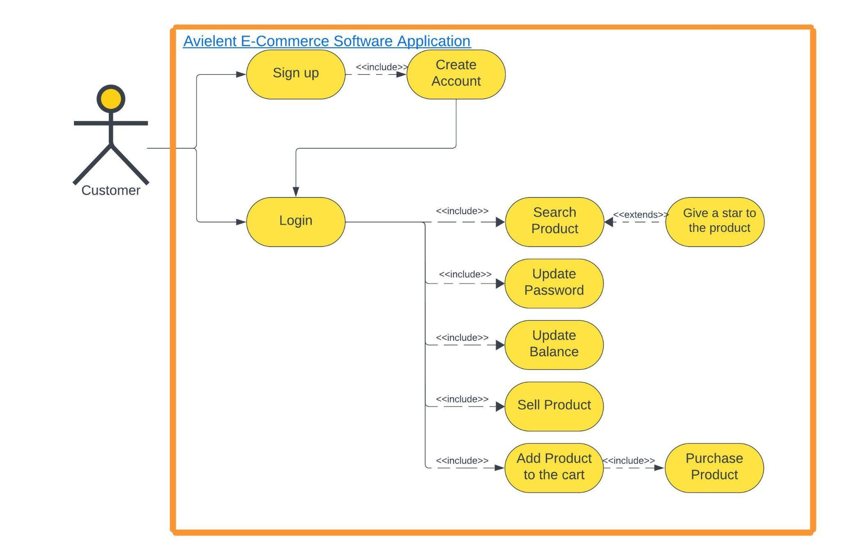

**ACTIVITY DIAGRAM**

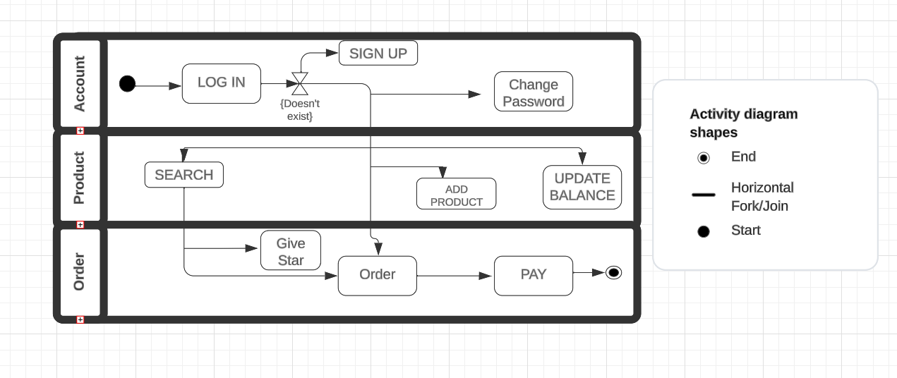

* 1. ***System Requirements Specification***

**SRS-AVEC-001.1**

AVEC will allow users to create a new account by requesting their email, username and password.

**SRS-AVEC-002.1**

AVEC will allow users to add the price and description of the product.

**SRS-AVEC-00.3.1**

AVEC will allow users to view the following information regarding the product they are searching for:

* Name of the product
* Producer Name
* Seller Name
* Stock
* Price
* Star
* Explanation

**SRS-AVEC-00.4.1**

AVEC will determine whether the product can be purchased according to the users' balance.

**SRS-AVEC-005.1**

AVEC will check the balance values entered by users.

**SRS-AVEC-007.1**

AVEC will check whether the two entered passwords are the same.

**SRS-AVEC-009.1**

AVEC will calculate the total given stars and give a score based on these star averages.